1. You’ve been hired by Flipkart to work on their recommendation system for books. Your first task is to see if you can predict the recommendations of a single user, using the following two attributes: Genre (Romance, Classic, or Thriller) and Price (High, Medium, or Low). The classification is whether the user recommended the book or not.

What is the P ( Recommended | Thriller, Medium) = ___________________.

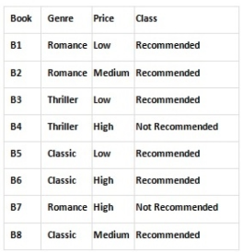

1. In the above question, What is the P ( Not Recommended | Thriller, Medium) = _______________.
2. What do you understand by linear separability?
3. Consider the set of following training examples:

|  |  |  |  |
| --- | --- | --- | --- |
| Instances | Feature 1 | Feature 2 | Class |
| 1 | T | F | - |
| 2 | T | F | - |
| 3 | T | T | + |
| 4 | F | F | - |
| 5 | F | T | + |
| 6 | F | F | - |
| 7 | T | F | - |

Use Naïve Bayes algorithm to predict the class for the following sample-

|  |  |  |  |
| --- | --- | --- | --- |
| Instances | Feature 1 | Feature 2 | Class |
| 8 | T | T | ? |

1. The values of independent variable x and dependent value y are given below:

| **X** | **Y** |
| --- | --- |
| **0** | **1** |
| **1** | **2** |
| **2** | **2** |
| **3** | **3** |
| **4** | **3** |
| **5** | **4** |

Find the least square regression line y=ax+b. Estimate the value of y when x is 15.

1. Take a regression dataset from kaggle and implement linear regression.
2. Take a classification dataset from kaggle and classify the data into output classes.

Also evaluate the classifier efficiency using various evaluation measures.

1. List all the various activation functions for firing of a neuron. Explain the various activation functions that are often used in machine learning models.
2. Write the Perceptron Learning algorithm and explain.
3. What are various Loss functions that are commonly used in Neural Networks? Explain.